Dan Kenworthy Scholarship  Lakota West Marching Band Merit  Scholarship Application  Name:____________________________________________________  Instrument:________________________________________________ | 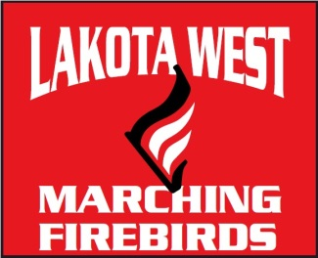
The Dan Kenworthy Scholarship is a $500 scholarship awarded to the outstanding Marching Band senior who best displays the following qualities both on and off the field: Dedication, Hardworking, Helpful, Supportive, Giving, Charitable, Kind, Friendly, Loving, Outgoing, Cheerful, Vivacious, Humor, Family Oriented.

All marching band seniors are invited to apply for the Dan Kenworthy Scholarship. Selection will be made based on your responses to the following questions and consultation with band directors and volunteers for the top candidates.

Please type your responses on a separate page (if possible) and attach to this application. Applications should be emailed to Andrew.carr@lakotaonline.com or handed in person to Mr. Carr no later than Thursday, November 1, 2018.

Application Questions:
- Please provide several examples which demonstrate your dedication, hard work, and willingness to go above and beyond what is expected of everyone in the marching band.

- Which other students (use names) have you personally helped and in what ways? Please provide examples of how you have displayed the qualities listed above to help other students. We may consult with these students if you are one of the top candidates.

- How have you helped band volunteers and supported the band program? Please provide examples of how you have displayed the qualities listed above in supporting the band program.

- Which director knows you and your contributions to the marching band best?

- Which band volunteers have you worked with most closely and should be consulted on your application if you are one of the top candidates?

Applications for the 2018 Marching Bard Season should be submitted no later than Thursday, November 1, 2018 to Andrew.carr@lakotaonline.com or in person to Mr. Carr.

