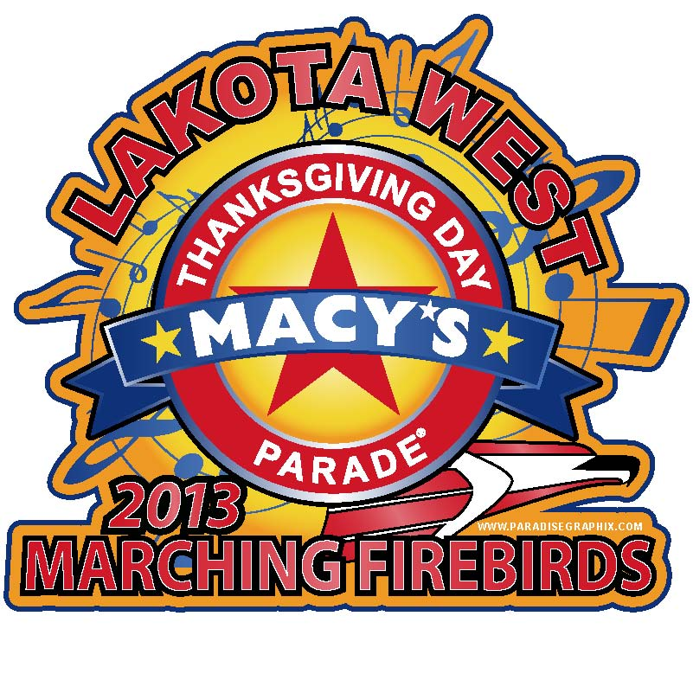 MACY’S FAQs (10/1/13, Updated)

When is the trip and what will be on the itinerary?
Students will depart 5am Monday November 25, 2013 and return Saturday November 30, 2013 mid morning. They will miss 2 days of school. The itinerary is posted on the website. http://www.lakotawestbands.org/finances/macys-trip-payments/

What is the cost of the trip?
The student package cost is $950.

Where is the band staying?
The band will be staying at the Sheraton Lincoln Harbor Hotel, 500 Harbor Boulevard, Weehawken, NJ 07086

Who will chaperone and what do they pay?
Parents have been selected to chaperone and have been background checked. We have a 12-1 ratio. Chaperones pay the same as the student cost, $950.

When will trip payments be due?
Your final payment is due October 31, 2013. Upbeat will be paying the final payment to Gateway 2 weeks before this date. All travelers must be paid in full, with any checks cleared, before getting on the bus in November. There are no payment plans that go beyond mid November. Payments of any amount can be made through your Charms account.

What are the links to the prescription forms needed if my student needs to take meds on the trip?
Available from Mr. Chumley or online at http://www.neola.com/lakotabutler-oh/ (click 5000, 5330, form 5330 F1 or F3-inhaler)

How much spending money does my student need?
Students will need to pay for 3 lunches in NY; $30-$50 should cover this. Any additional spending money is discretionary.

How much luggage can/should my student bring?
Students should pack 1 bag approximately as big as their red bag and bring a small bag for bus items/things needed for the day in NY. Uniform items will be pre packed and shipped on a truck with the large instruments.

What should my student pack?
See separate dress code information. All uniform items will be collected and packed after the final marching band competition/concert. Large instruments will be packed on the truck and shipped the weekend before Thanksgiving. Students will need to pack a lunch and snacks to eat on the bus Monday 11/25; the bus ride is ~12 hours.

Who is my student’s chaperone and how do I contact them if I need to?
We will have a pre trip meeting on 10/8/13 at 7pm at the Freshman Auditorium. You will find out who your chaperone is and meet them if you attend. Students are encouraged to attend. We are collecting all student and parent cell numbers for the trip. Your chaperone will have both student and parent numbers. Students will have chaperone numbers. The best way to contact your student’s chaperone is by text as there will be times we won’t be able to have a ringer on.

If I am in NY can I see, talk to, or contact my student?
The best way is by cell phone. Followers will have some shared activities. With some pre planning (text) you can meet in an area where we are sharing an activity to exchange cash or conversation. Others will need to plan to be where we are at the same time. No students are allowed to leave the group/activity without Mr. Snyder’s permission.

If we have family or other plans and want to leave early with our student for NY and meet the band OR stay longer in NY and not have them ride the bus home can we do that?
Yes, we had families do that for our Disney trip. You will need to inform Mr. Snyder and your student’s chaperone of your plans as the time gets near to make arrangements. The most likely exchange points will be at the band’s hotel at check-in and check-out times. This will not change the cost of the trip as the bus costs the same whether there are 49 or 50 people on it and it is Upbeat policy not to prorate trip costs or offer “ala carte” pricing.

Does Macy’s take/offer an official parade picture of the band for purchase?
Yes, and a video, you order direct. http://www.groupphotos.com/special and http://www.groupphotos.com/special/show/1738 If either link does not work in Firefox, try it in Internet Explorer. Clicking “continue” on the first link in Mozilla did not bring up Lakota West in the picklist. In IE it does.

What Broadway shows will the followers/students see?
Lion King, Phantom, Spiderman.

Will there be a “followers package” available?
The follower’s package is full. The itinerary can be found here. http://www.lakotawestbands.org/finances/macys-followers-payments/

What is a followers package?
This is a package that provides transportation (buses separate from the band), hotel (separate from the band, but nearby), and some shared activities with the band. The buses and hotel are separate to keep the band focused on their tasks and taking undistracted direction from band staff while traveling.

Does the package include “parade seating/viewing?”
No, seating is “on your own.” Seating can not be reserved or purchased. The hotel is about 4 blocks from Macy’s where the band will do the “performance” portion of the parade route. That is why the hotel was chosen for this package.

What is the follower’s bus schedule?
The followers bus will arrive at 5:30am and leave Lakota West HS on 11/25 at 6am (1 hr after the band) arriving in NY around 6pm and departing the Westin Grand Central 7pm on 11/29 and arriving Lakota West around 7am 11/30.

What is the cost of the follower’s bus and who can sign up?
The follower’s bus costs $130/person. We have room. The NON REFUNDABLE payment is being collected. You don’t need to sign up for a follower’s package to ride the bus. http://www.signupgenius.com/go/4090548AFAF29A46-interest

If we don’t want to book the followers package because we can save money on hotels and other things with hotel points and rewards plans, but there are activities in the followers package we would really like to do with the band (Thanksgiving dinner, Broadway show) is there a way we can pay to do that?
Unfortunately there is not. This is an “all or nothing” package and there are no ala carte options. Gateway prices these things together to get us the deal they do and it would become impossible for Upbeat to manage payment plans for individual items for every person wanting a personalized plan. Some of these things are absolutely not permitted to be sold outside of the package even if we wanted to, the Thanksgiving dinner is one of them.

If I purchased the followers package can I use/receive hotel reward points?
Not for anything purchased in the package. You may use/receive award points only for incidental charges (in room dining, movies, restaurant charges, etc.) because the room and tax for the hotel are paid through the group contract. Present your rewards card upon check-in.

