Weatherwax Scholarship  Lakota West Bands Merit Scholarship Application  Name:____________________________________________________  Instrument:________________________________________________  Concert Band: ______________________________________________ | 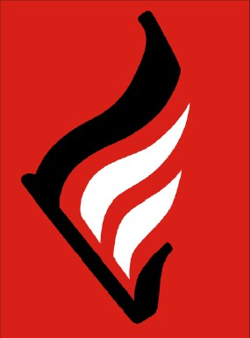
Bill Weatherwax was a band dad who loved being a part of the Lakota West band programs. Bill started by volunteering for Solo & Ensemble and later joined the Pit Crew. He enjoyed the experience so much that he added band camp, trips, and he was gearing up to chair his favorite, Jazz ‘N Cakes. His gentle and kind spirit was evident in everything he did and he was always asking how he could help his fellow band parents whether that was carrying a heavy bag, loading another instrument, or helping another chaperone. It is in remembrance of that spirit of volunteerism and cheerful service that we honor his memory with this scholarship to a deserving senior.

The Bill Weatherwax Memorial Scholarship is a $500 scholarship awarded to a graduating senior from a concert band who exemplifies the spirit of volunteerism and cheerful service. This is a student who shows up to help without being asked, the one who is there early to set up, pitches in when they see a need, does the dirty jobs no one else wants, gets others to help, stays late to clean up, and is the student who is always reliable or who can be counted on. S/he does this repeatedly and cheerfully and often when no one is looking, it’s a part of who they are.

All concert band seniors are invited to apply for the Bill Weatherwax Memorial Scholarship. Selection will be made based on your responses to the following questions and consultation with band directors and volunteers for the top candidates.

Please type (if possible) your responses on a separate page and attach to this application. Applications should be emailed to president@lakotawestbands.org (an email confirming receipt will be sent) or given to Mr. Carr no later than one week prior to the band awards. The scholarship will be awarded at the band awards program in May.

Application Questions:
- Please list the fundraisers you have supported over your career as a band student and what you did for each fundraiser (Jazz N’ Cakes, Mattress Sale, Tag Day, Swing Dance, etc).

- Please list service activities you have engaged in to support the band program. Consider things like setting up for or working at Solo & Ensemble, loading equipment for offsite trips, concerts or contests, helping with uniforms, coaching others.

- How have you helped band volunteers and supported the band program? Please provide examples of how you have cheerfully supported the band program other than those listed above.

- Which director knows you and your contributions to concert band best?

- Which band volunteers have you worked with most closely and should be consulted on your application if you are one of the top candidates?

